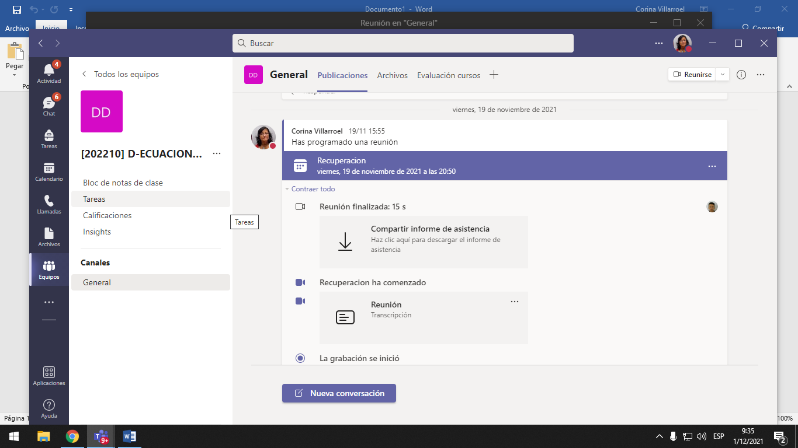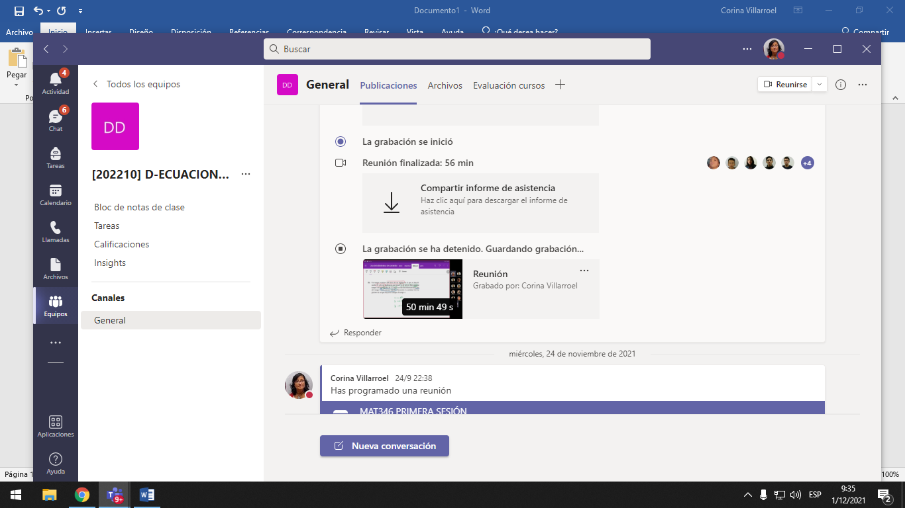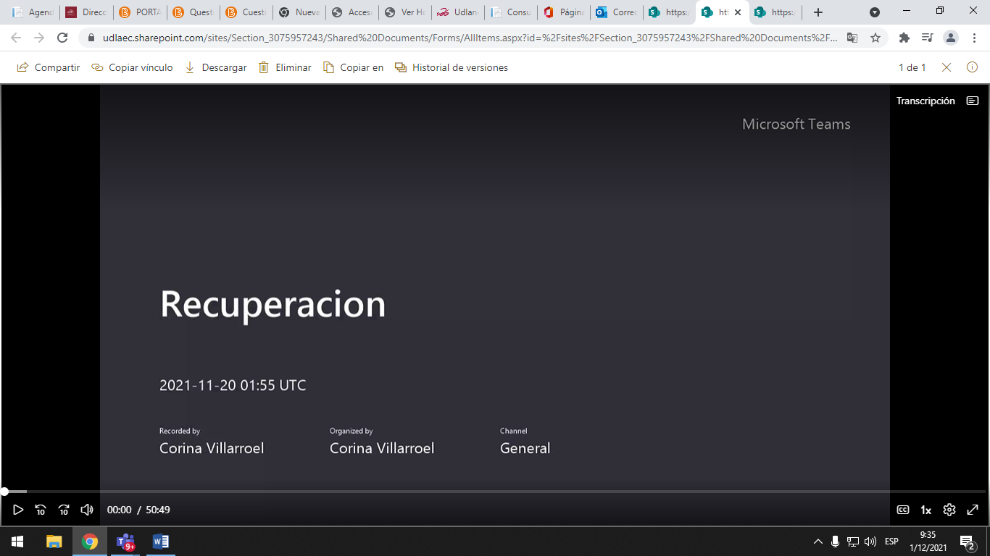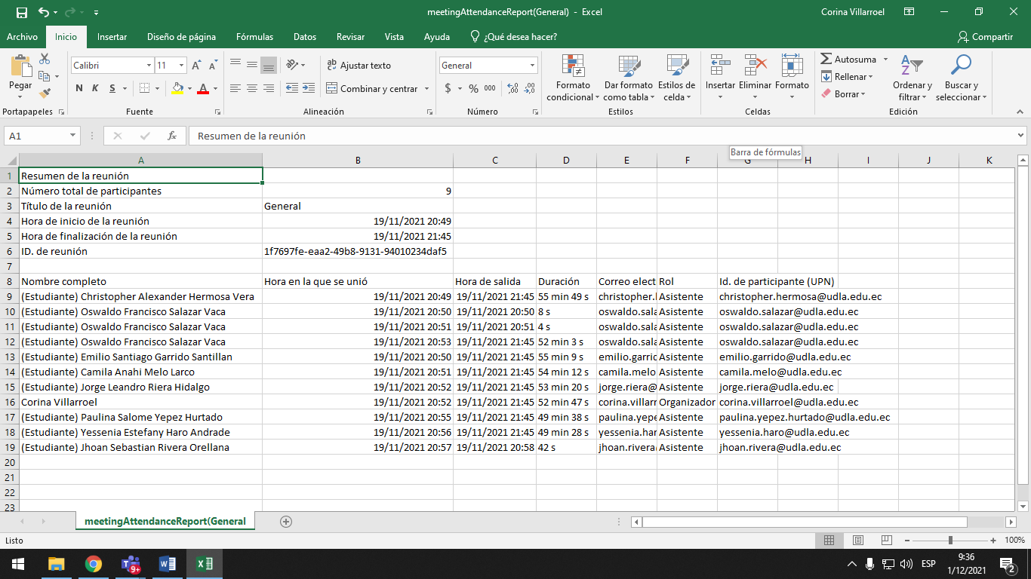
Adjunto vinculo de la grabación
https://udlaec.sharepoint.com/:v:/r/sites/Section_3075957243/Shared%20Documents/General/Recordings/Recuperacion-20211119_205454-Grabaci%C3%B3n%20de%20la%20reuni%C3%B3n.mp4?csf=1&web=1&e=dbiEaH

